Lab 2 – Web Server and Designing Web Pages

**Task 1: Install and configure XAMPP.**

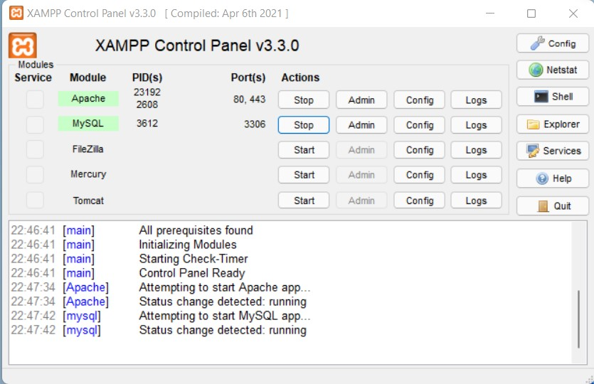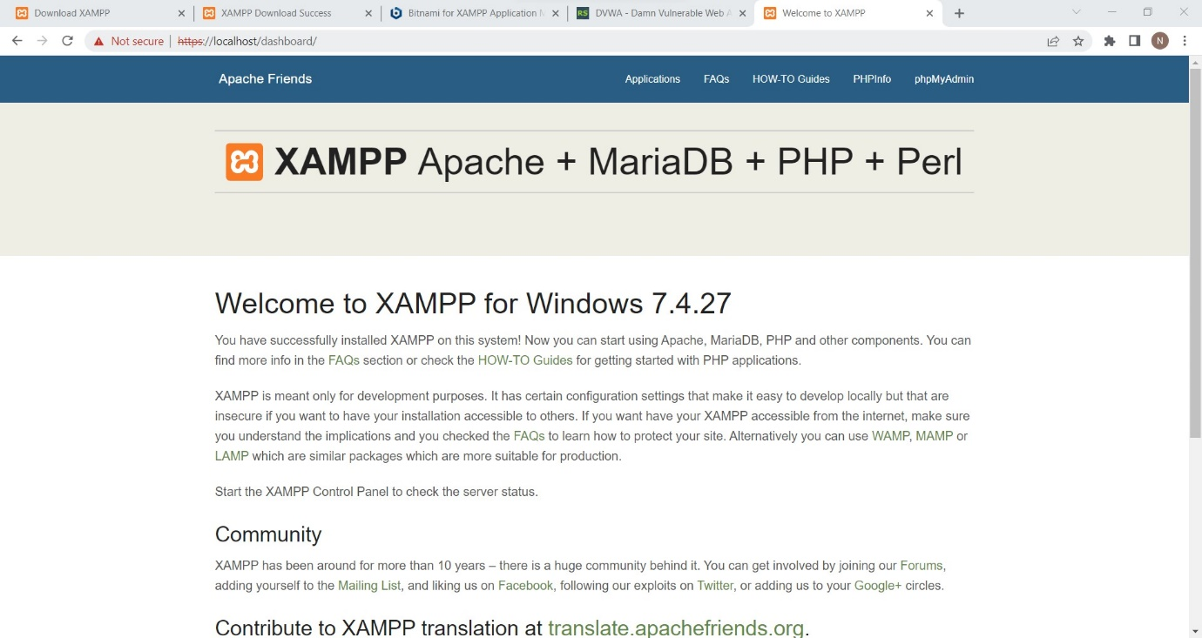Download XAMPP exe file and install it. Do the required configuration to start Apache and MySQL.

**Task 2: Download and configure DVWA website in local.**

Download Damn Vulnerable Web Application (DVWA) in your local machine and do appropriate configuration to connect this application to the database. You can attach the screenshot of login page here.

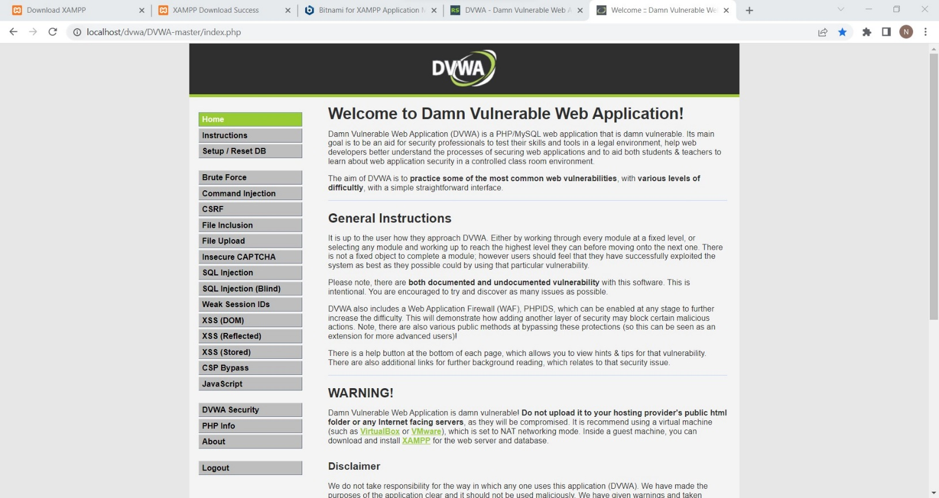

**Task 3: Create a small website with at least 3 web pages.**

Create 3 webpages.

1. a. The first page should be a Sign-Up page with “Sign Up” button and a reference link to login page.
2. b. The second page should be a Login page with “Login” button and a reference link to Sign Up page.
3. c. The third page should be a Home page with a “Logout” button.

